Chapter 3
Analysis and Requirements Engineering
This chapter consolidates the analysis and requirements engineering of the two AI subsystems that constitute the graduation project: Part A — the Retrieval-Augmented Generation (RAG) Tutor, and Part B — the Quiz Generation Subsystem. It defines stakeholders, functional and non-functional requirements, data requirements, user stories, use cases, business requirements, system constraints, assumptions, traceability, and UML specifications for both subsystems, derived from their respective architecture references. The chapter documents what the systems must do and why, rather than how they are internally implemented.
3.1 Stakeholder Analysis
3.1.1 Part A — RAG Tutor Stakeholders
Stakeholder | Goals | Pain Points | Expectations / Benefits
Student | Accurate, evidence-grounded answers and tutoring over uploaded materials. | Hallucinated content; difficulty locating information in long documents. | Citation-backed answers, voice/text interaction, cross-document concept linking.
Educator / Instructor | Ensure answers align with curated course content. | Lack of control over AI output; fabricated content risk. | Faithful grounding, prerequisite-aware reasoning, transparent source attribution.
Administrator | Manage users, subjects, and operational health. | Multi-tenant leakage risk; operational complexity. | Per-user isolation, lifecycle visibility, graceful failure modes.
AI Engineer / Developer | Extend retrieval, embedding, and LLM components. | Tightly coupled, opaque pipelines. | Modular layered architecture with independent components.
Educational Institution | Uphold academic integrity and data-protection policy. | Hallucination undermines credibility; opaque AI threatens governance. | Evidence-based answering, explainability, auditability.

Table 3.1 — RAG Tutor stakeholder analysis.
3.1.2 Part B — Quiz Generation Subsystem Stakeholders
Stakeholder | Goals | Expectations
Students | Practice with quizzes generated from their study material. | Accurate, well-formed MCQs aligned with content and cognitive level.
Educators / Instructors | Automate assessment creation from course documents. | Pedagogically valid questions covering Bloom's Taxonomy levels.
System Administrators | Operate the platform reliably. | Stable, observable, scalable services with controlled costs.
AI Engineers | Maintain and improve the generation and validation pipeline. | Modular architecture, reproducible inference.
Educational Institution | Adopt AI-assisted assessment at scale. | Compliance, content quality, cost-effective deployment.

Table 3.2 — Quiz Generation stakeholder analysis.
3.2 Functional Requirements (Use Case Modelling)
3.2.1 Part A — RAG Tutor Functional Requirements
ID | Description | Priority | Stakeholder
FR-A-001 | Allow authenticated users to upload educational documents into per-user, per-subject libraries. | High | Student, Educator
FR-A-002 | Accept PDF, DOCX, PPTX, TXT, and CSV documents and route them to the correct parser. | High | Student, Educator
FR-A-003 | Validate file existence, type, and parser compatibility before processing. | High | Administrator
FR-A-004 | Apply OCR to scanned pages and to images embedded in PDF, DOCX, and PPTX files. | High | Student, Educator
FR-A-005 | Apply multi-stage text cleaning (Unicode, ligatures, OCR artefacts, hyphenation, boilerplate, headers/footers, garbage lines, math, bullets, whitespace) to normalise extracted content. | High | AI Engineer
FR-A-006 | Partition cleaned text into semantically coherent chunks using sentence-embedding boundary detection, and generate structured chunk metadata. | High | AI Engineer
FR-A-007 | Extract entities and relationships and persist them in a property graph scoped by user, subject, and document. | High | Student
FR-A-008 | Construct cross-document relationships within each subject through a second-pass graph augmentation. | High | Student, Educator
FR-A-009 | Expose lifecycle status (PROCESSING, COMPLETED, FAILED) for every knowledge-graph build. | High | Administrator
FR-A-010 | Perform dense vector retrieval and sparse lexical retrieval over the chunk corpus. | High | Student
FR-A-011 | Fuse dense and sparse rankings with a scale-invariant rank-fusion mechanism and apply cross-encoder reranking. | High | Student
FR-A-012 | Translate questions into focused subgraphs through entity recognition, multi-level seed matching (exact, substring, highest degree, first available), and hop-bounded multi-hop traversal. | High | Student
FR-A-013 | Scope every retrieval operation to the subject of the active user session. | High | Administrator
FR-A-014 | Construct a unified evidence context that combines retrieved chunks and graph relationships into a single LLM prompt. | High | Student
FR-A-015 | Maintain conversational sessions with ordered chat history bound to a user and subject. | High | Student
FR-A-016 | Classify queries as DEPENDENT or INDEPENDENT and rewrite dependent queries into self-contained form (pronoun resolution, entity recovery, context injection). | High | Student
FR-A-017 | Detect greetings, classify question complexity, and decompose complex questions into atomic sub-questions. | High | Student
FR-A-018 | Generate citation-backed responses identifying source documents, chunk indices, and page references. | High | Student, Educator, Institution
FR-A-019 | Provide a composite confidence indicator with each generated answer. | High | Student
FR-A-020 | Constrain generation to retrieved evidence and prevent hallucinated content. | High | Student, Institution
FR-A-021 | Detect insufficient evidence and return an explicit uncertainty response ("I don't know"). | High | Student, Institution
FR-A-022 | Support an answer-orchestration mode that selects, agrees, or fuses RAG and KG answers using a defined decision tree. | Medium | AI Engineer
FR-A-023 | Return a structured response containing answer, confidence, citations, focused subgraph, and entity/relation counts. | High | Student, AI Engineer
FR-A-024 | Provide context-aware tutoring grounded in the subject corpus, surfacing prerequisite chains and concept dependencies. | High | Student, Educator
FR-A-025 | Accept text queries through a chat interface and audio queries via speech-to-text, optionally returning text-to-speech responses. | High | Student
FR-A-026 | Generate answers in the user's language (multilingual support). | High | Student
FR-A-027 | Integrate with an external web-search service to augment local knowledge when evidence is insufficient. | Medium | Student
FR-A-028 | Apply documented fallback strategies at every pipeline stage and log per-stage diagnostics without surfacing errors to the user. | High | Administrator, AI Engineer

Table 3.3 — RAG Tutor functional requirements (FR-A-001 to FR-A-028).
3.2.2 Part B — Quiz Generation Functional Requirements
ID | Description | Priority | Source
FR-B-001 | Accept document uploads in PDF, DOCX, PPTX, TXT and CSV formats. | High | Students, Educators
FR-B-002 | Extract textual content using format-specific parsers. | High | AI Engineers
FR-B-003 | Apply OCR to image-based or scanned content. | High | Educators
FR-B-004 | Clean and normalise extracted text. | High | AI Engineers
FR-B-005 | Segment content into semantic chunks within defined size bounds. | High | AI Engineers
FR-B-006 | Extract metadata for each chunk. | High | Educators
FR-B-007 | Classify each chunk against Bloom's Taxonomy cognitive level. | High | Educators
FR-B-008 | Generate MCQs using a slot-based prompting strategy. | High | Students, Educators
FR-B-009 | Produce one correct answer and plausible distractors per question. | High | Students
FR-B-010 | Validate generated MCQs through a multi-stage validation pipeline. | High | Educators, AI Engineers
FR-B-011 | Exclude questions that fail validation. | High | AI Engineers
FR-B-012 | Deduplicate semantically similar questions. | Medium | Educators
FR-B-013 | Construct a supervised fine-tuning dataset from validated MCQs. | Medium | AI Engineers
FR-B-014 | Serve MCQs through a fine-tuned student model at runtime. | High | Students
FR-B-015 | Expose generation and retrieval endpoints to the application backend. | High | Administrators, AI Engineers
FR-B-016 | Persist generated quizzes and metadata for later retrieval. | High | Students, Educators
FR-B-017 | Report and log errors across the pipeline. | High | Administrators

Table 3.4 — Quiz Generation functional requirements (FR-B-001 to FR-B-017).
3.3 Non-Functional Requirements
3.3.1 Part A — RAG Tutor Non-Functional Requirements
ID | Dimension | Statement
NFR-A-001 | Performance | Reranking operates only on a bounded candidate pool produced by rank fusion to keep cost proportional to pool size.
NFR-A-002 | Performance | Graph retrieval is hop-bounded to prevent exponential expansion in densely connected subjects.
NFR-A-003 | Accuracy | Every answer is grounded in retrieved textual or graph evidence; hallucination-prevention rules are enforced in the prompt.
NFR-A-004 | Accuracy | Semantic chunking with adaptive breakpoints preserves topical coherence within each chunk.
NFR-A-005 | Accuracy | Cross-document concept linking is performed for multi-document subjects to support cross-lecture reasoning.
NFR-A-006 | Reliability | Every pipeline stage implements a documented failure-handling strategy and either degrades gracefully or terminates with a descriptive status.
NFR-A-007 | Availability | Single-source retrieval failures trigger automatic fallback to the remaining retrieval channel.
NFR-A-008 | Scalability | The vector store and the graph database scale independently as corpora grow; cross-document linking adapts to subject size (all-pairs vs. consecutive).
NFR-A-009 | Security & Privacy | Authentication scopes all reads and writes; user, subject, and document data are partitioned at both the relational and graph layers.
NFR-A-010 | Maintainability | Each pipeline stage is independently deployable and testable through well-defined interfaces.
NFR-A-011 | Portability & Interoperability | Storage uses widely supported open technologies; external LLM, STT/TTS, and web-search services are integrated through substitutable interfaces.
NFR-A-012 | Usability | Responses include human-readable citations, confidence indicators, and entity context, and accept natural follow-up questions.
NFR-A-013 | Monitoring & Fault Tolerance | Build operations expose lifecycle states; the fusion stage produces a valid response across text-only, graph-only, both-empty, and LLM-failure cases.
NFR-A-014 | Compliance | Evidence-based answering and explicit uncertainty responses align with academic-integrity and AI-governance expectations; source attribution is persisted for auditability.
NFR-A-015 | Quality Evaluation | Retrieval is evaluated using Hit@1, Hit@K, and MRR; answer generation is evaluated using Precision, Recall, F1-score, Faithfulness, Exact Match (EM), and Contain Match.

Table 3.5 — RAG Tutor non-functional requirements.
3.3.2 Part B — Quiz Generation Non-Functional Requirements
ID | Category | Requirement
NFR-B-001 | Performance | MCQ generation requests complete within acceptable interactive latency.
NFR-B-002 | Scalability | The pipeline supports horizontal scaling of stateless workers.
NFR-B-003 | Reliability | The validation pipeline rejects malformed or low-quality questions consistently.
NFR-B-004 | Availability | The generation service remains available through retries, queuing, and stateless worker redundancy.
NFR-B-005 | Security | API endpoints enforce authentication and authorisation.
NFR-B-006 | Maintainability | The pipeline is modular, with clearly separated parsing, generation and validation stages.
NFR-B-007 | Portability | Components run on both GPU and CPU environments with graceful fallback.
NFR-B-008 | Interoperability | The subsystem integrates with the application backend through documented APIs.
NFR-B-009 | Data Quality | Generated MCQs conform to a fixed schema and pedagogical criteria.
NFR-B-010 | AI Output Quality | Questions align with the Bloom level inferred for each chunk.
NFR-B-011 | Observability | All pipeline stages emit logs sufficient for diagnosis.
NFR-B-012 | Cost Efficiency | Runtime inference is served by the fine-tuned student model, eliminating per-request external API costs.

Table 3.6 — Quiz Generation non-functional requirements.
3.4 Data Requirements
3.4.1 Data Sources and Acquisition
Part A — RAG Tutor
Educational documents are acquired through authenticated upload in PDF, DOCX, PPTX, TXT, and CSV formats. OCR-acquired content is extracted from scanned pages and embedded images via the recognition engine. Structured chunk metadata, knowledge-graph entities and relationships, and conversational session data are produced automatically during ingestion and runtime. Every input is validated for existence, supported type, and parser compatibility before processing begins.
Part B — Quiz Generation
Inputs include PDF, DOCX, PPTX, TXT and CSV files uploaded by students or instructors. Scanned or image-bearing content is processed by OCR. Extracted text is normalised and segmented into chunks within defined size bounds before further processing. The teacher model (Gemini 2.5 Flash Lite) is invoked exclusively during offline dataset construction to acquire candidate MCQs; runtime inference acquires no external generation data.
3.4.2 Data Volumetric and Diversity Requirements
Part A — RAG Tutor
The system must accommodate multiple subjects per user, an arbitrary number of documents per subject, and multilingual content. Cross-document support is a first-class requirement: a dedicated linking pass unifies isolated document graphs into a coherent subject graph. Noise tolerance is essential — the cleaning pipeline compensates for Unicode artefacts, ligatures, OCR substitution errors, broken hyphenation, boilerplate, headers and footers, garbage lines, and inline mathematical fragments. OCR output is expected to be usable but never assumed clean. Data completeness is enforced through validation: empty text or zero chunks aborts the build with FAILED rather than producing a degraded graph.
Part B — Quiz Generation
The fine-tuning dataset is constructed from validated MCQs and must cover the Bloom levels relevant to the subsystem, balance difficulty across cognitive levels, and ensure topical diversity across source documents. Only items that pass every stage of the validation pipeline are admitted to the dataset, providing implicit class balance and a controlled noise profile. Volumetric expansion across experimental versions (corpus curation and augmentation) is governed by the validation pipeline rather than by raw collection size.
3.4.3 Data Annotation and Labelling Standards
Part A — RAG Tutor
Chunk metadata follows a typed schema (source type, page boundaries, text, word and token counts, semantic-coherence score). Entities are labelled with name, type, description, source document, and subject. Relationships carry a typed directed edge drawn from a controlled vocabulary (e.g. PREREQUISITE_TO, BUILDS_UPON, EXTENDS, USES, DEPENDS_ON, RELATED_TO) with description, source, and cross-document flag. Citations identify document, chunk index, and pages. Graph metadata records ownership and lifecycle status. Schema enforcement at the persistence layer and deterministic upsert semantics preserve consistency.
Part B — Quiz Generation
Each MCQ follows a fixed schema (stem, four options, correct answer, distractors, and metadata). Each chunk carries metadata for topic, key concepts, and Bloom level. The validation pipeline enforces these standards before any item enters storage or the training dataset, guaranteeing that all labels conform to the schema and that pedagogical criteria — including Bloom alignment, single-correct-answer, and distractor plausibility — are satisfied.
3.5 User Stories
3.5.1 Part A — RAG Tutor
Student
• As a student, I want to upload my course materials in multiple formats so that I can query them in one place.
• As a student, I want citation-backed answers so that I can trust and verify each response.
• As a student, I want to ask follow-up questions using pronouns so that I can converse naturally.
• As a student, I want the system to tell me when it does not know rather than fabricate an answer.
• As a student, I want to see prerequisite relationships across my lectures so that I can plan my learning.
• As a student, I want to interact by voice and in my preferred language.
Instructor
• As an instructor, I want answers to remain bounded to my curated materials so that the assistant does not contradict my course.
• As an instructor, I want concept relationships extracted across my lecture series so that students can navigate dependencies.
Administrator / AI Engineer
• As an administrator, I want each user's documents, sessions, and graphs isolated and I want to monitor the lifecycle of every build.
• As an AI engineer, I want each pipeline stage to be modular and to log per-stage diagnostics for debugging.
3.5.2 Part B — Quiz Generation
Student
• As a student, I want to upload my study material so that I receive quizzes generated from it.
• As a student, I want questions to cover different cognitive levels so that I can practise both recall and reasoning.
Instructor
• As an instructor, I want to generate assessments from course documents to reduce manual question authoring.
• As an instructor, I want questions to be validated automatically so that low-quality items are filtered out.
Administrator
• As an administrator, I want the service to scale and recover from transient failures so that users experience uninterrupted access.
AI Engineer
• As an AI engineer, I want a curated dataset constructed from validated MCQs to fine-tune the student model.
3.6 Use Case Descriptions
3.6.1 Part A — RAG Tutor Use Cases
ID | Use Case | Actor | Goal
UC-01 | Upload Educational Document | Student / Instructor | Add a document to a subject and build vector and graph representations.
UC-02 | Submit Text Query | Student | Ask a question via the chat interface.
UC-03 | Submit Audio Query | Student | Ask a question by voice; optionally receive a spoken answer.
UC-04 | Receive Citation-Backed Answer | Student | Obtain an evidence-grounded response with explicit source references.
UC-05 | Request Educational Assistance | Student | Receive tutoring guidance and concept-dependency information.
UC-06 | Retrieve Knowledge Graph Context | System | Translate a question into a focused subgraph.
UC-07 | Perform Hybrid Retrieval | System | Combine dense + sparse retrieval with reranking to select top-K chunks.
UC-08 | Receive Context-Aware Response | Student | Receive an answer that respects multi-turn context.
UC-09 | Use Conversational Follow-Up Query | Student | Ask a dependent question relying on prior turns.
UC-10 | Access Web-Augmented Knowledge | Student | Augment local evidence with external web search when needed.

Table 3.7 — RAG Tutor use case summary.
UC-01 Upload Educational Document
Goal: build vector and graph representations of an uploaded document. Primary actor: Student or Instructor. Supporting components: parser, OCR engine, embedding model, LLM extractor, vector store, graph database. Precondition: user authenticated; subject exists. Trigger: user uploads file. Main flow: validation → parser routing → text extraction → OCR (conditional) → cleaning → semantic chunking → metadata + embedding + vector persistence in parallel with KG-chunking + entity/relationship extraction + graph persistence → optional cross-document linking (>1 document) → status COMPLETED. Alternative: cross-document linking runs only when subject has more than one document. Exception: unsupported type, empty text, zero chunks, or persistence failure terminate with FAILED. Postcondition: the document is queryable via both retrieval channels.
UC-02 Submit Text Query
Goal: receive a grounded response to a text question. Actor: Student. Precondition: active session bound to a subject. Trigger: user submits a question. Main flow: session validation → chat history retrieval → dependency classification → rewriting (if dependent) → greeting/intent detection → complexity classification → decomposition (if complex) → concurrent hybrid retrieval and KG retrieval → evidence-level fusion → single LLM generation → structured response. Alternative: greeting-only inputs short-circuit to a greeting response. Exception: insufficient evidence yields an explicit "I don't know". Postcondition: user receives answer with citations and confidence.
UC-03 Submit Audio Query
Goal: ask by voice. Actor: Student. Supporting: STT, TTS. Trigger: audio submitted. Main flow: STT transcription → standard UC-02 flow → optional TTS playback. Alternative: user may switch modality mid-session. Exception: STT/TTS failure degrades to text-only mode. Postcondition: answer delivered in chosen modality.
UC-04 Receive Citation-Backed Answer
Goal: deliver an auditable response. Actor: Student. Trigger: completion of generation. Main flow: assemble citations from retrieval metadata → attach focused subgraph, entity and relation counts → deliver structured response. Alternative: citations may include cross-document references. Exception: if citations cannot be built, uncertainty response is returned. Postcondition: each answer is auditable.
UC-05 Request Educational Assistance
Goal: tutoring with concept dependencies. Actor: Student. Precondition: subject KG with cross-document edges exists. Trigger: tutoring-style question (e.g. prerequisites). Main flow: entity recognition → seed selection → hop-bounded traversal → answer generation grounded in focused subgraph plus supporting chunks. Alternative: related-concept suggestions surfaced via cross-doc edges. Exception: if KG coverage is missing, fall back to text-only retrieval. Postcondition: structured explanation with narrative and relationships.
UC-06 Retrieve Knowledge Graph Context
Goal: produce a focused subgraph. Actor: System. Precondition: non-empty subject KG. Trigger: retrieval-ready query. Main flow: entity recognition + fallback hints → multi-level seed selection (exact → substring → highest degree → first available) → hop-bounded traversal → graph focusing → structured graph context. Exception: no seeds found returns empty graph context; generation proceeds on text only. Postcondition: bounded subgraph available for the unified prompt.
UC-07 Perform Hybrid Retrieval
Goal: select top-K chunks. Actor: System. Trigger: retrieval-ready query. Main flow: concurrent dense and sparse retrieval → rank fusion → cross-encoder reranking → top-K assembly. Exception: dense failure falls back to sparse; sparse failure falls back to dense; reranker failure uses fused order. Postcondition: ranked top-K chunks ready for fusion.
UC-08 Receive Context-Aware Response
Goal: answer that respects prior turns. Actor: Student. Trigger: follow-up question. Main flow: history retrieval → dependency classification → rewriting → retrieval and generation on rewritten query → response. Alternative: independent queries skip rewriting. Exception: classification failure defaults to INDEPENDENT. Postcondition: multi-turn coherence preserved.
UC-09 Use Conversational Follow-Up Query
Goal: resolve dependent queries. Actor: Student. Trigger: query with pronouns or continuation cues. Main flow: dependency classifier detects pronouns → query rewriter substitutes referents and restores implicit topic → forwarded to retrieval. Alternative: greeting-plus-question inputs are split. Exception: rewriting failure preserves the original query. Postcondition: follow-up resolved as a standalone query.
UC-10 Access Web-Augmented Knowledge
Goal: augment with external web search. Actor: Student. Precondition: web-search enabled. Trigger: insufficient local evidence or explicit user request. Main flow: issue web search for the rewritten query → add snippets to unified prompt → generation produces an answer that may cite web sources. Exception: search service unreachable falls back to local evidence or returns the uncertainty response. Postcondition: answer integrates local and web evidence with clear attribution.
3.6.2 Part B — Quiz Generation Use Cases
ID | Use Case | Primary Actor
UC-Q-05 | Upload Document | Student / Instructor
UC-Q-06 | Generate Quiz from Document | Student / Instructor
UC-Q-07 | Validate and Regenerate MCQs | System (AI Engineer oversight)
UC-Q-08 | Run Fine-Tuned Student Model Inference | System

Table 3.8 — Quiz Generation use case summary.
UC-Q-06 Generate Quiz from Document
Trigger: A user requests quiz generation for an uploaded document. Main flow: the system parses the document, segments it into semantic chunks, extracts metadata, classifies each chunk by Bloom level, generates MCQs through the slot-based strategy, validates each MCQ, regenerates failures, deduplicates, and returns the validated quiz to the caller. Postcondition: a validated set of MCQs is stored and delivered to the user.
UC-Q-07 Validate and Regenerate MCQs
Trigger: A candidate MCQ is produced by the generator. Main flow: the MCQ traverses the multi-stage validation pipeline; failures trigger bounded regeneration; passing items are added to the output set; semantically duplicate items are filtered.
UC-Q-08 Run Fine-Tuned Student Model Inference
Trigger: A generation request is routed to the student model. Main flow: the system loads the fine-tuned model, runs inference on GPU when available with CPU fallback otherwise, and returns generated MCQs to the validation pipeline. Exception flow: if the student model is unavailable, the request fails with an error and is retried by the caller; the system does not route runtime requests to the teacher model.
3.7 Business Requirements
3.7.1 Part A — RAG Tutor
The system must deliver accurate, evidence-grounded answers aligned with the uploaded curriculum, support active tutoring through prerequisite and concept-dependency surfacing, and provide explainability via citations, entities, and relationship paths. Transparency requires explicit uncertainty responses when evidence is absent. Evidence-based answering and source attribution support academic integrity and AI governance, while data-protection requirements, per-user isolation, and reliance on widely supported open storage technologies satisfy institutional constraints.
3.7.2 Part B — Quiz Generation
The subsystem must automate assessment creation, align outputs with Bloom's Taxonomy, support institutional adoption, and operate cost-effectively. AI governance is achieved through layered validation and through a teacher–student distillation strategy in which the teacher model is used only to construct the training dataset, while runtime inference relies exclusively on the fine-tuned student model.
3.8 System Constraints
3.8.1 Part A — RAG Tutor
The system depends on an external LLM service for extraction, rewriting, decomposition, and generation; on a property-graph database with hop-bounded traversal semantics; on a relational database augmented with a vector extension; and on external OCR, speech, and web-search services. Hardware resources determine embedding and reranking throughput, and all performance targets are implementation-defined. Every retrieval operation is constrained to the subject of the active session, precluding cross-subject queries within a single conversation. Storage must accommodate growth without coupling between vector and graph stores.
3.8.2 Part B — Quiz Generation
• AI models: a teacher model (Gemini 2.5 Flash Lite) is used exclusively during dataset construction; a fine-tuned student model (Qwen2.5-1.5B) handles all runtime inference.
• Hardware: the runtime supports both GPU and CPU execution.
• External dependencies: dataset construction depends on the availability of the Groq and Gemini APIs; runtime inference does not depend on external generation APIs.
• Deployment: the subsystem integrates with a FastAPI Python service, an ASP.NET Core backend and a Flutter client.
• Storage: validated quizzes, metadata and datasets are persisted in the platform storage layer.
3.9 Assumptions and Dependencies
3.9.1 Part A — RAG Tutor
Uploaded educational content is assumed to be of acceptable quality and relevant to its subject. Internet connectivity and the availability of external LLM, STT/TTS, and web-search services are assumed during runtime, with documented fallbacks for transient failures. The relational, vector, and graph databases are assumed to be reachable; user authentication infrastructure is assumed to provide reliable identities used for data partitioning; and session persistence is assumed to maintain ordered chat history across turns.
3.9.2 Part B — Quiz Generation
• The fine-tuned student model is available and loadable at runtime; the system does not fall back to the teacher model for live requests.
• External APIs (Groq, Gemini) are reachable with acceptable latency during dataset construction and training.
• Uploaded content is legible enough for parsing or OCR.
• The application backend exposes the integration points expected by the subsystem.
3.10 Requirement Traceability Matrix
3.10.1 Part A — RAG Tutor Traceability
ID | Requirement | Stakeholder | Use Case | Component | Verification
FR-A-001 | Document upload | Student, Educator | UC-01 | Document Processing | Functional test
FR-A-002 | Multi-format parsing | Student, Educator | UC-01 | Parser Layer | Format-coverage test
FR-A-003 | Pre-build validation | Administrator | UC-01 | Validation Gate | Negative test
FR-A-004 | OCR processing | Student | UC-01 | OCR Layer | Scanned-corpus test
FR-A-005 | Text cleaning | AI Engineer | UC-01 | Cleaning module | Unit tests
FR-A-006 | Semantic chunking + metadata | AI Engineer | UC-01 | Chunking Pipeline | Boundary evaluation
FR-A-007 | Entity & relationship extraction | Student | UC-01 | KG Construction | Graph audit
FR-A-008 | Cross-document relationships | Student, Educator | UC-01, UC-05 | Cross-Document Pipeline | Multi-doc graph audit
FR-A-009 | KG lifecycle status | Administrator | UC-01 | Status manager | Lifecycle test
FR-A-010 | Dense + sparse retrieval | Student | UC-02, UC-07 | Retrieval Layer | Retrieval metrics
FR-A-011 | Rank fusion + reranking | Student | UC-07 | Fusion + Reranker | Precision evaluation
FR-A-012 | KG retrieval + multi-hop | Student | UC-06 | KG Retrieval | Subgraph audit
FR-A-013 | Subject-scoped retrieval | Administrator | UC-02 to UC-09 | Session manager | Isolation test
FR-A-014 | Evidence-level fusion | Student | UC-04 | Fusion module | Prompt-assembly test
FR-A-015 | Session state | Student | UC-08, UC-09 | Session manager | Persistence test
FR-A-016 | Dependency classification + rewriting | Student | UC-09 | Conv. Intelligence | Classification accuracy
FR-A-017 | Intent, complexity, decomposition | Student | UC-02 | Conv. Intelligence | Functional test
FR-A-018 | Citation-backed responses | Student, Institution | UC-04 | Response builder | Citation audit
FR-A-019 | Confidence indicator | Student | UC-04 | Response builder | Score-presence test
FR-A-020 | Hallucination prevention | Student, Institution | UC-04 | Prompt rules | Faithfulness evaluation
FR-A-021 | Uncertainty response | Student, Institution | UC-04 | Generation guardrail | Insufficient-evidence test
FR-A-022 | Answer orchestration | AI Engineer | UC-04 | Orchestrator | Routing-decision test
FR-A-023 | Structured response schema | Student | UC-04 | Response schema | Schema validation
FR-A-024 | Tutoring + prerequisite surfacing | Student, Educator | UC-05 | Tutoring layer | Scenario evaluation
FR-A-025 | Text + audio interfaces | Student | UC-02, UC-03 | UI + STT/TTS | Functional test
FR-A-026 | Multilingual answers | Student | UC-02, UC-04 | Generation prompt | Multilingual evaluation
FR-A-027 | Web-search augmentation | Student | UC-10 | Web-search integration | Fallback test
FR-A-028 | Graceful degradation + logging | Administrator | All UCs | Pipeline fallbacks | Fault-injection test

Table 3.9 — RAG Tutor requirement traceability matrix.
3.10.2 Part B — Quiz Generation Traceability
Requirement | Stakeholder | Use Case | Component | Verification
FR-B-001 | Students, Educators | UC-Q-05 | Parsing layer | Functional test
FR-B-002 – FR-B-004 | AI Engineers | UC-Q-05, UC-Q-06 | Parsing & cleaning | Functional test
FR-B-005 – FR-B-007 | AI Engineers, Educators | UC-Q-06 | Chunking & metadata | Functional test
FR-B-008 – FR-B-009 | Students, Educators | UC-Q-06 | Generation | Functional & quality test
FR-B-010 – FR-B-012 | Educators, AI Engineers | UC-Q-07 | Validation | Functional & quality test
FR-B-013 | AI Engineers | UC-Q-07 | Dataset builder | Inspection
FR-B-014 | Students | UC-Q-08 | Inference service | Functional test
FR-B-015 – FR-B-016 | Administrators, AI Engineers | UC-Q-06 | API & storage | Integration test
FR-B-017 | Administrators | All | Cross-cutting | Log inspection
NFR-B-001 – NFR-B-012 | All | All | All components | Measurement & review

Table 3.10 — Quiz Generation requirement traceability matrix.
3.11 UML Diagram Specifications
Diagrams are described textually as specified by the thesis documentation standard.
3.11.1 Part A — RAG Tutor UML Specifications
Figure 3.1: Use Case Diagram — RAG Tutor
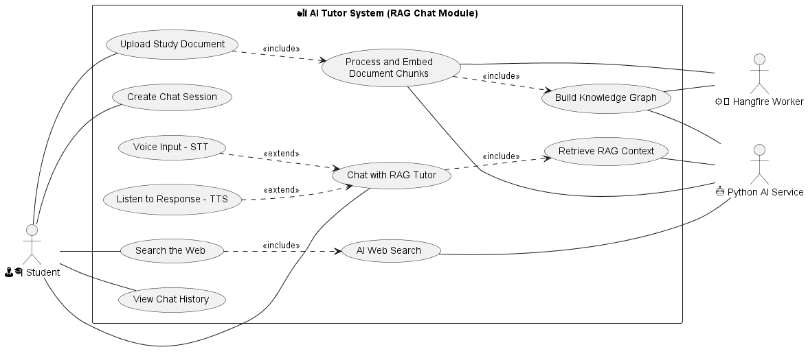
Purpose: capture functional scope from an external-actor view. Actors: Student, Instructor, Administrator, plus the external LLM and Web Search services at the periphery. Use cases: UC-01 to UC-10 within the system boundary. Relationships: UC-02 «include» UC-06 and UC-07 (every text query invokes both retrieval channels); UC-02 «include» UC-04 (every successful query produces a structured response); UC-09 «extend» UC-02 (rewriting is conditional on dependency); UC-03 «extend» UC-02 (audio queries reuse the text flow after transcription); UC-10 «extend» UC-02 (web augmentation is conditional). UC-01 associates Student and Instructor; the Administrator supervises UC-01 lifecycle.
Figure 3.2: Activity Diagram — Document Processing and Knowledge Construction
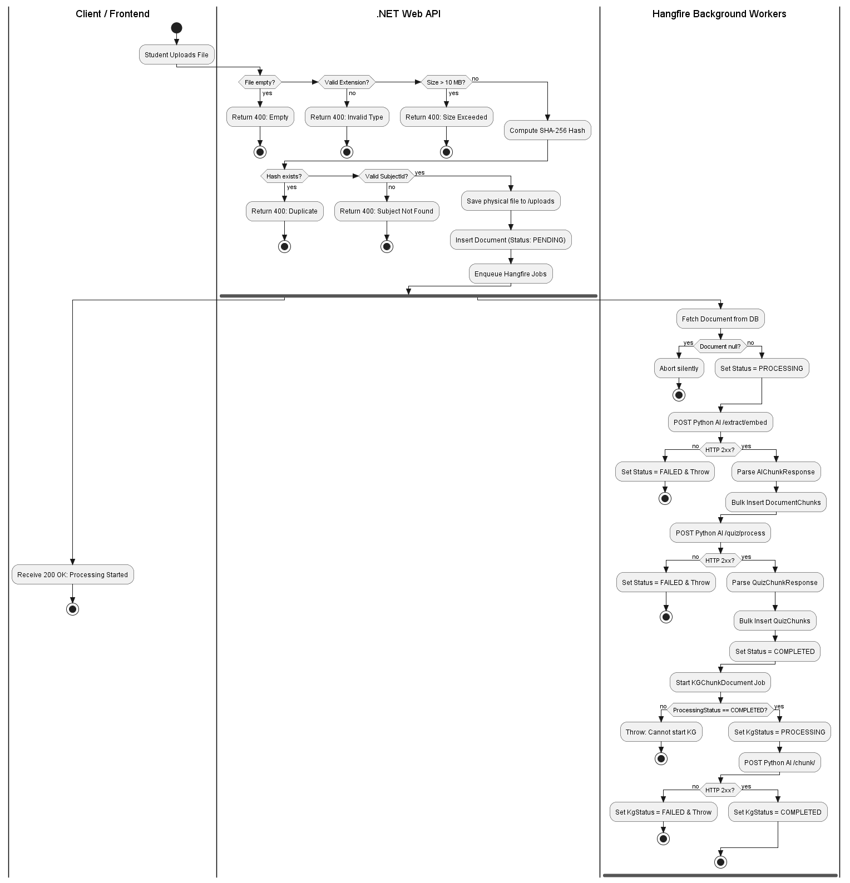
Purpose: model the offline construction workflow. Initial node receives an uploaded file; activities flow through Validation → Parser Routing → Text Extraction → conditional OCR → Cleaning. A fork splits into two parallel branches: the vector branch (Semantic Chunking → Metadata → Embedding → Vector Persistence) and the graph branch (KG-specific Chunking → LLM Entity/Relationship Extraction → Graph Persistence → conditional Cross-Document Linking when the subject contains more than one document). Branches synchronise at a join node that sets status COMPLETED. Any failure transitions to an Abort node with FAILED and diagnostic logging.
Figure 3.3: Activity Diagram — End-to-End Query Processing Flow
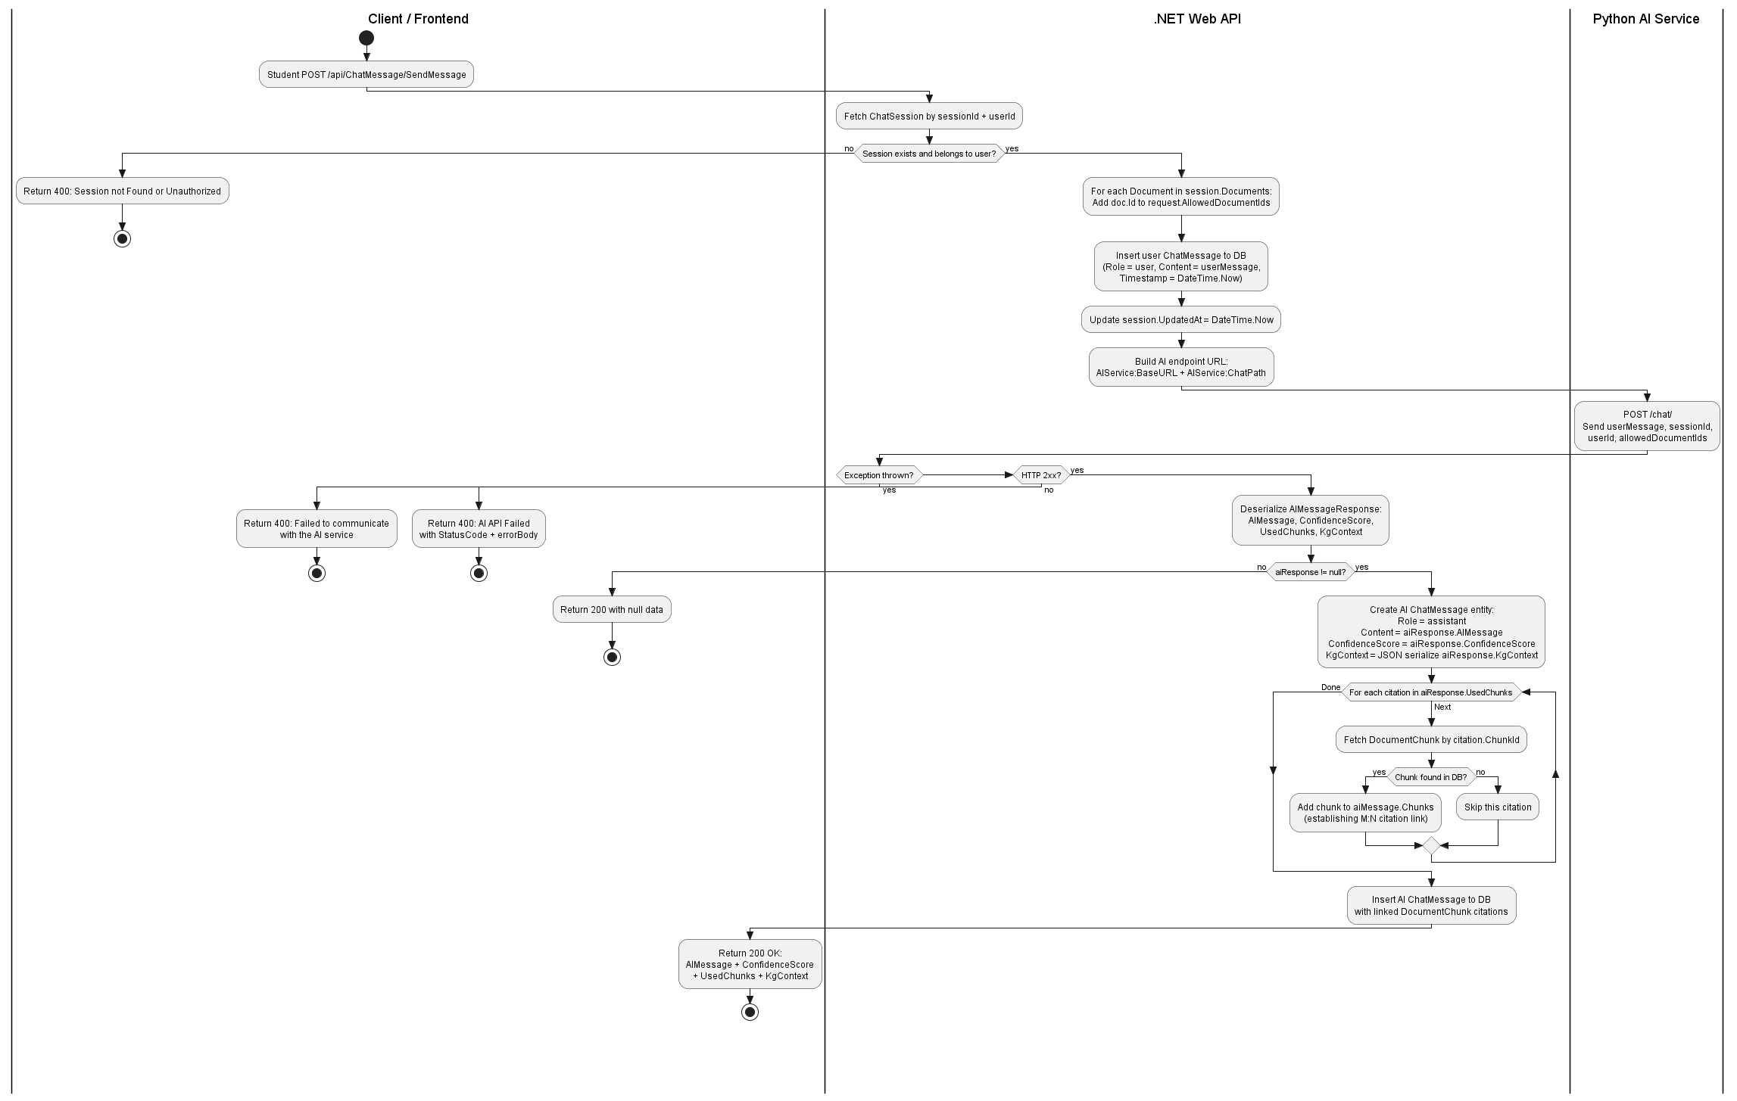
Purpose: model the runtime QA workflow. Initial node receives the query; activities flow through Session Validation → Chat History Retrieval → Dependency Classification (decision: rewrite or pass through) → Greeting/Intent Detection (greeting-only short-circuits to a Greeting Response) → Complexity Classification → optional Decomposition. For each (sub-)query the flow forks into Hybrid Retrieval and KG Retrieval, which synchronise into Hybrid Context Fusion → single LLM Answer Generation → Citation and Confidence Construction → Response Delivery. A pre-fusion decision node handles four cases: text-only context, graph-only context, both empty (uncertainty response), and LLM failure (uncertainty response with logging).
Figure 3.4: Component Diagram — RAG Tutor Architecture

Purpose: depict principal runtime and offline components and their connectors. Components: User Interface (text and voice); Conversational Intelligence Layer (session manager, dependency classifier, query rewriter, intent/complexity detectors, decomposer); Retrieval Layer (embedding service, dense retriever, sparse retriever, rank-fusion, cross-encoder reranker); Knowledge Graph Layer (entity recogniser, seed selector, traversal engine, graph focuser); Vector Database (relational store with vector extension); Relational Database (documents, sessions, chat history); Knowledge Graph Database (entities, relationships, cross-document edges); LLM Services; Web Search Layer; Response Generation Layer (hybrid context fusion, answer generator, citation/confidence builder, orchestrator, response schema). Relationships: the UI depends on the Conversational Intelligence and Response Generation layers; Conversational Intelligence depends on the Relational Database and LLM Services; Retrieval depends on the Vector Database; KG Layer depends on the Graph Database; both retrieval layers feed Response Generation, which depends on LLM Services and optionally on Web Search. Offline ingestion components depend on LLM Services for extraction and on the Vector and Graph Databases for persistence. Ownership scoping is enforced through structural user-subject-document nodes in the graph and user/subject filters in the relational and vector stores.
3.11.2 Part B — Quiz Generation UML Specifications
Figure 3.5: Use Case Diagram — Quiz Generation Subsystem
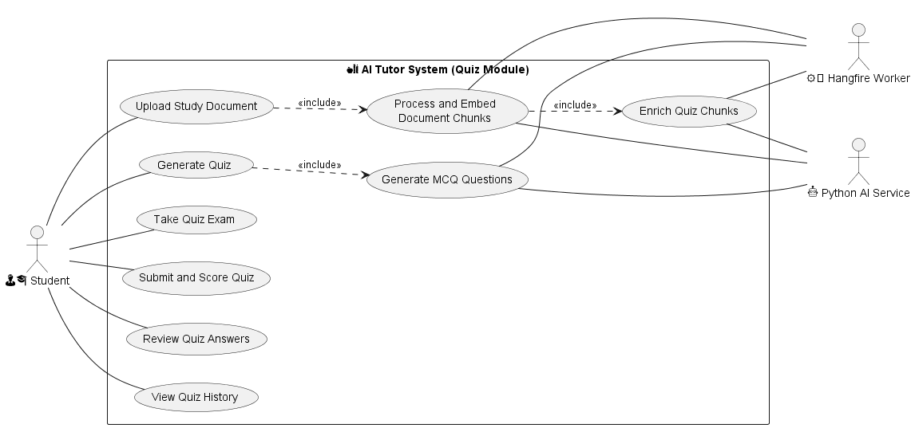
Actors: Student, Instructor, Administrator, AI Engineer, and the System (acting on behalf of internal services). Use cases: UC-Q-05 Upload Document, UC-Q-06 Generate Quiz, UC-Q-07 Validate and Regenerate, UC-Q-08 Run Fine-Tuned Inference. UC-Q-06 «include» UC-Q-07 and UC-Q-08; UC-Q-08 is always served by the fine-tuned student model.
Figure 3.6: Activity Diagram — Document Processing and Generation
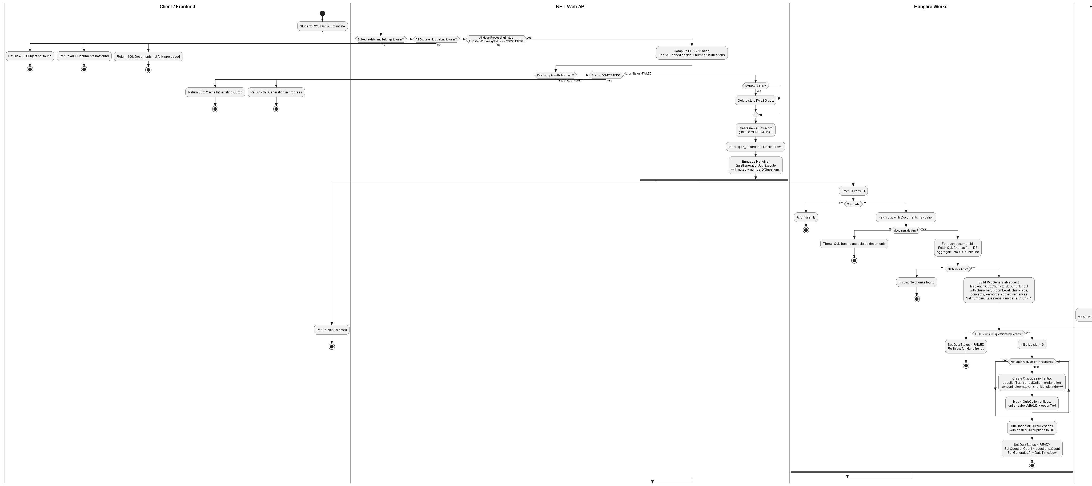
Flow: receive document → parse by format → apply OCR if needed → clean and normalise → segment into semantic chunks → extract metadata and Bloom level → generate MCQs per chunk → hand off to the validation pipeline.
Figure 3.7: Activity Diagram — Validation and Regeneration
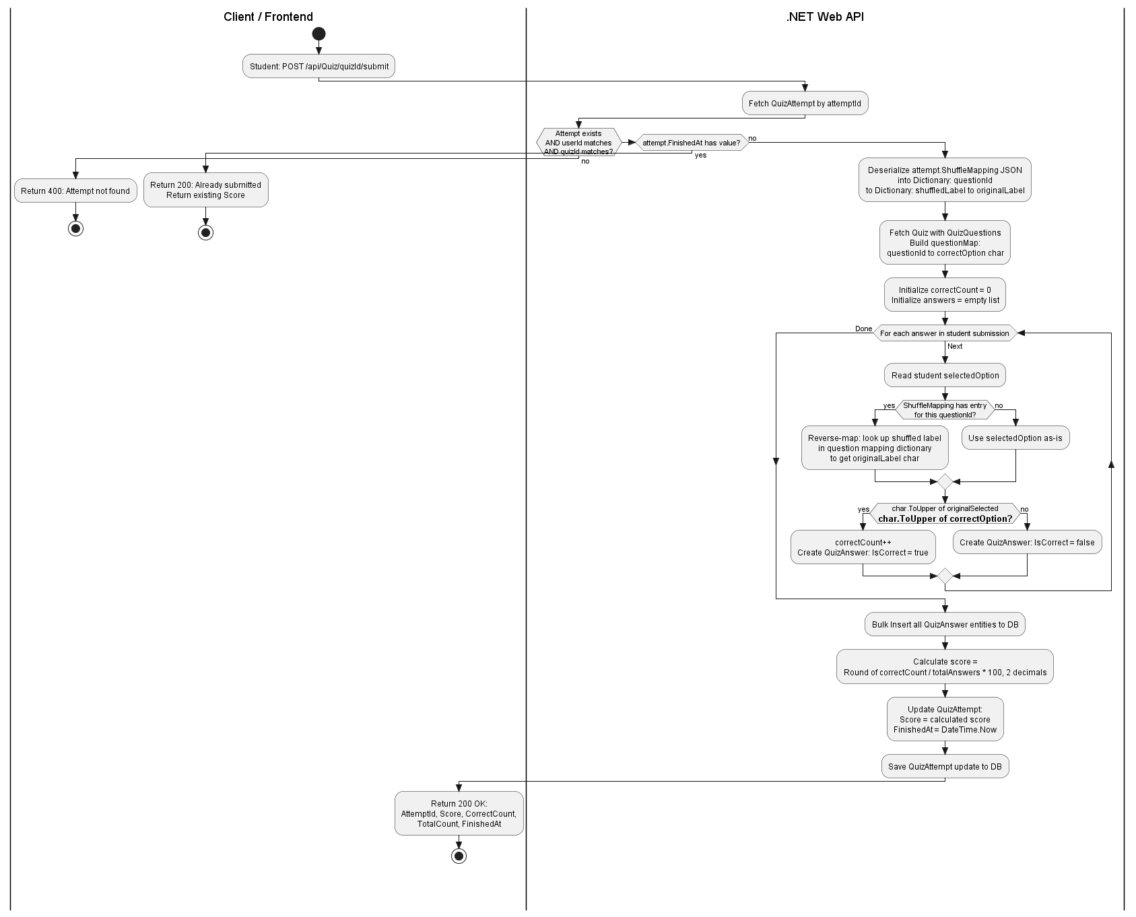
Flow: receive candidate MCQ → run multi-stage validation → on failure, request bounded regeneration → on success, deduplicate against existing items → add to the quiz output → persist.
Figure 3.8: Deployment and Integration Diagram
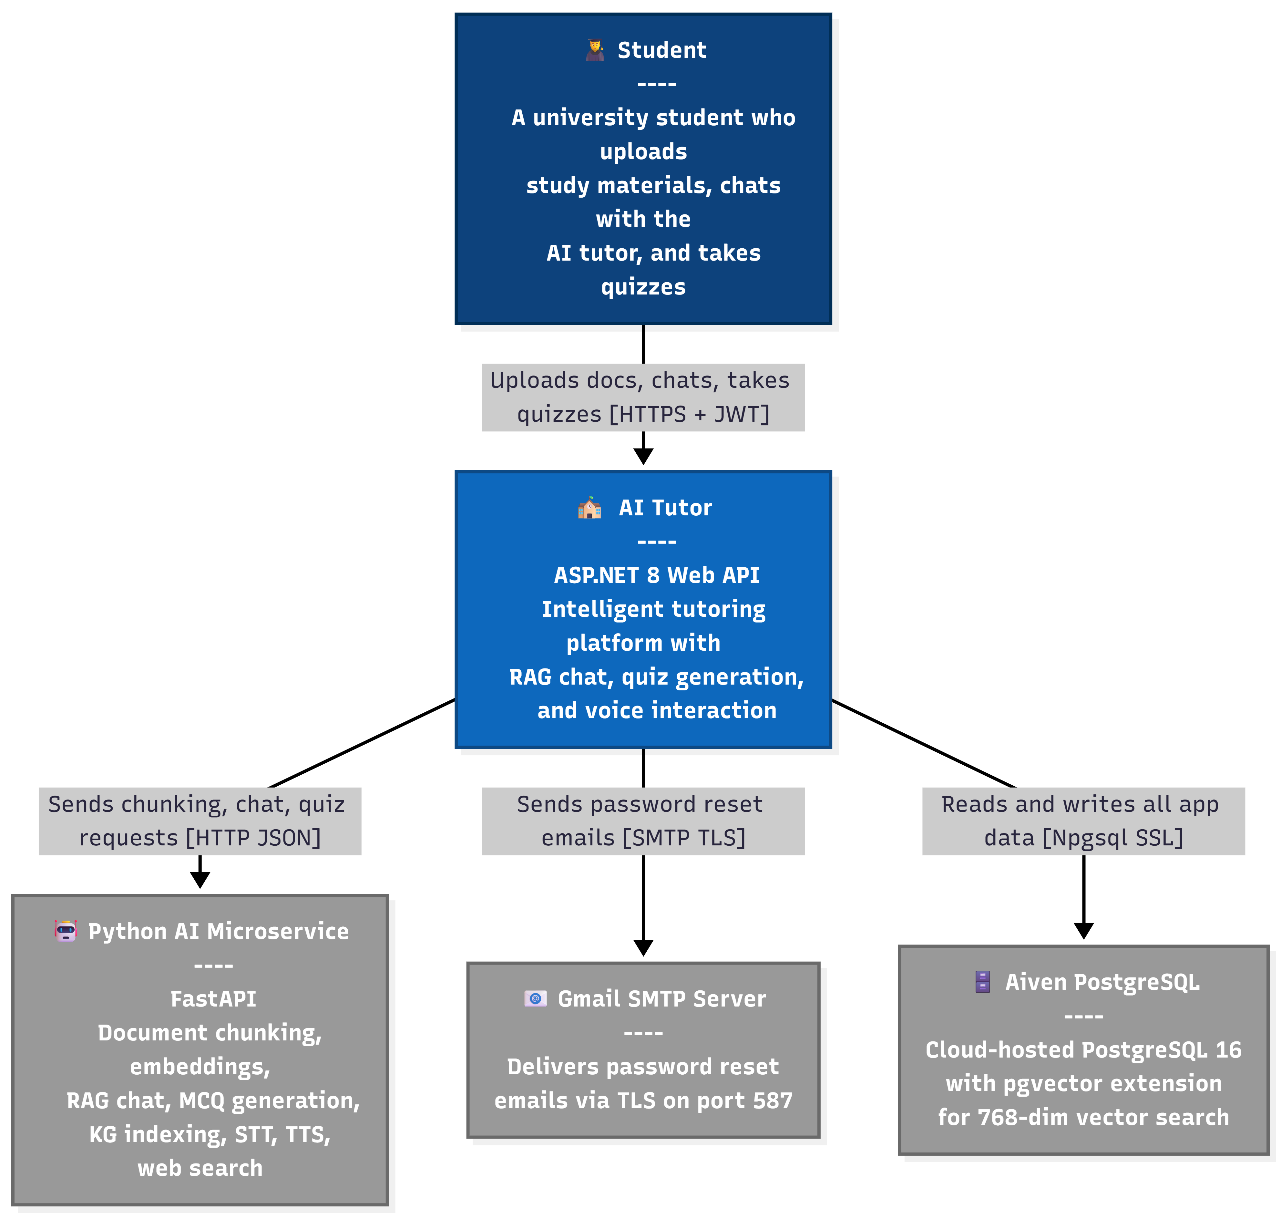
Components: Flutter client, ASP.NET Core backend, and FastAPI Python AI service hosting the fine-tuned student model. External Groq and Gemini APIs are used only in the offline dataset construction and training pipeline; they are not part of the runtime request path. At runtime, data flows from the client through the backend to the AI service, which returns validated MCQs back through the backend to the client.

